**Use Case Diagram:**

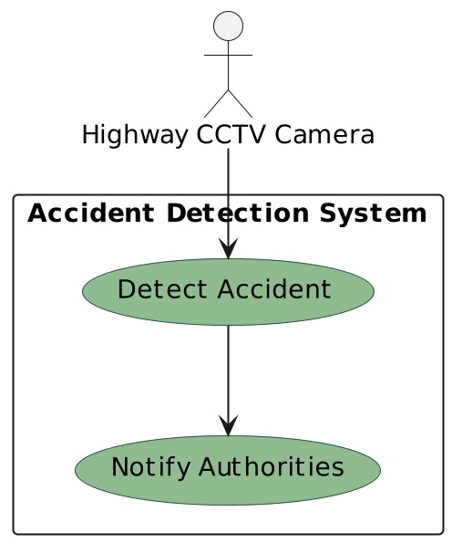

1. **Actors**:
   * **Highway CCTV Camera**: Represents the device that captures live video footage of the highway.
2. **Use Cases**:
   * **Detect Accident**: This use case represents the system's ability to analyze the live video feed captured by the Highway CCTV Camera to detect accidents. It encapsulates the process of identifying and recognizing accident-related events in the video footage.
   * **Notify Authorities**: This use case represents the system's capability to inform the relevant authorities or emergency services about detected accidents. It involves initiating communication or sending alerts to notify appropriate personnel or systems about the occurrence of an accident.
3. **Interactions**:
   * **Highway CCTV Camera --> Detect Accident**: The Highway CCTV Camera actor interacts with the Detect Accident use case by providing the live video feed. This interaction triggers the system to analyze the video feed and detect accidents.
   * **Detect Accident --> Notify Authorities**: Once an accident is detected, the Detect Accident use case interacts with the Notify Authorities use case. This interaction indicates that the system should notify the relevant authorities or emergency services about the detected accident.
4. **System Functionality**:
   * The Accident Detection System encapsulates the functionalities related to accident detection and notification. It serves as the core component responsible for processing the live video feed, identifying accidents, and initiating notifications.

Overall, the Use Case Diagram provides a visual representation of the system's functionalities and interactions with its users (actors). It helps stakeholders understand the scope of the system and the primary actions it can perform to achieve its objectives, such as detecting accidents and notifying authorities.